SQL> SET serveroutput on

SQL> /* Drop tables, sequence, and other objects you create*/

SQL> DROP TABLE OrderDetails;

Table ORDERDETAILS dropped.

SQL> DROP TABLE Item;

Table ITEM dropped.

SQL> DROP TABLE CustomerOrder;

Table CUSTOMERORDER dropped.

SQL> DROP TABLE ItemType;

Table ITEMTYPE dropped.

SQL> DROP TABLE Customer;

Table CUSTOMER dropped.

SQL> DROP SEQUENCE Customer_Seq;

Sequence CUSTOMER_SEQ dropped.

SQL> DROP SEQUENCE CustomerOrder_Seq;

Sequence CUSTOMERORDER_SEQ dropped.

SQL> DROP SEQUENCE OrderDetails_Seq;

Sequence ORDERDETAILS_SEQ dropped.

SQL> DROP SEQUENCE Item_Seq;

Sequence ITEM_SEQ dropped.

SQL> DROP SEQUENCE ItemType_Seq;

Sequence ITEMTYPE_SEQ dropped.

SQL> /* Create 5 tables */

SQL> CREATE TABLE Customer

(

Customer_ID NUMBER NOT NULL,

Cust_FName VARCHAR2 (50),

Cust_LName VARCHAR2 (50),

Cust_Address VARCHAR2 (100),

Cust_ZipCode VARCHAR2(10),

Cust_PhoneNum VARCHAR2(15),

Cust_Email VARCHAR2(50),

CONSTRAINT pk_customer PRIMARY KEY (Customer_ID)

);

Table CUSTOMER created.

SQL> COMMENT ON TABLE Customer IS 'Table used to store Customer information';

Comment on table customer 'TABLE USED TO STORE CUSTOMER INFORMATION' succeeded.

SQL> DESCRIBE Customer;

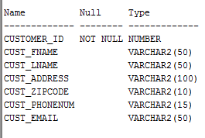

SQL> CREATE TABLE CustomerOrder

(

Customer_Order_ID NUMBER NOT NULL,

Order_Date DATE,

Customer_ID NUMBER NOT NULL,

CONSTRAINT pk_CustomerOrder PRIMARY KEY (Customer_Order_Id),

CONSTRAINT fk_Customer FOREIGN KEY (Customer_ID)

REFERENCES Customer

);

Table CUSTOMERORDER created.

SQL> COMMENT ON TABLE CustomerOrder IS

'Table used to store main order information for each customer';

Comment on table customerorder 'TABLE USED TO STORE MAIN ORDER INFORMATION FOR EACH CUSTOMER' succeeded.

SQL> DESCRIBE CustomerOrder;

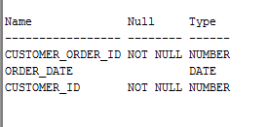

SQL> CREATE TABLE ItemType

(

Item_Type_ID NUMBER NOT NULL,

Type_Name VARCHAR2(50),

CONSTRAINT pk_ItemType PRIMARY KEY (Item_Type_ID)

);

Table ITEMTYPE created.

SQL> COMMENT ON TABLE ItemType IS

'Table serves as a lookup or reference for the type of item an item is';

Comment on table itemtype 'TABLE SERVES AS A LOOKUP OR REFERENCE FOR THE TYPE OF ITEM AN ITEM IS' succeeded.

SQL> DESCRIBE ItemType;

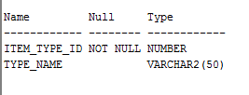

SQL> CREATE TABLE Item

(

Item_ID NUMBER NOT NULL,

Item_ListPrice NUMBER,

Item_Cost NUMBER,

Item_Name VARCHAR2 (50),

Item_Type_ID NUMBER,

Spec_Documents BLOB,

Total_Qty NUMBER,

Reorder_Qty NUMBER,

Date_Added DATE,

CONSTRAINT pk_Item PRIMARY KEY (Item_ID),

CONSTRAINT fk_ItemType FOREIGN KEY (Item_Type_ID)

REFERENCES ItemType

);

Table ITEM created.

SQL> COMMENT ON TABLE Item IS

'Used to list all the necessary properties belonging to each specific item';

Comment on table item 'USED TO LIST ALL THE NECESSARY PROPERTIES BELONGING TO EACH SPECIFIC ITEM' succeeded.

SQL> DESCRIBE Item;

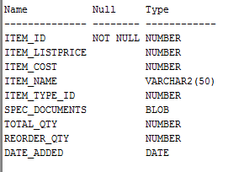

SQL> CREATE TABLE OrderDetails

(

Order_Details_ID NUMBER NOT NULL,

Order_Details_Qty NUMBER,

Discount NUMBER,

Item_ID NUMBER NOT NULL,

Customer_Order_ID NUMBER NOT NULL,

CONSTRAINT pk_OrderDetails PRIMARY KEY (Order_Details_ID),

CONSTRAINT fk_CustomerOrder FOREIGN KEY (Customer_Order_ID)

REFERENCES CustomerOrder,

CONSTRAINT fk_OrderItem FOREIGN KEY (Item_ID)

REFERENCES Item

);

Table ORDERDETAILS created.

SQL> COMMENT ON TABLE OrderDetails IS

'Contains the breakdown of each item ordered from CustomerOrder Table';

Comment on table orderdetails 'CONTAINS THE BREAKDOWN OF EACH ITEM ORDERED FROM CUSTOMERORDER TABLE' succeeded.

SQL> DESCRIBE OrderDetails;

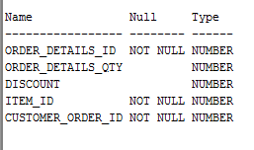

Index FK_CUSTOMER created.

SQL> CREATE INDEX fk_ItemType on Item(Item_Type_ID);

Index FK_ITEMTYPE created.

SQL> CREATE INDEX fk_CustomerOrder on OrderDetails(Customer_Order_ID);

Index FK_CUSTOMERORDER created.

SQL> CREATE INDEX fk_OrderItem on OrderDetails(Item_ID);

Index FK_ORDERITEM created.

SQL> /* Create sequence*/

SQL> CREATE SEQUENCE Customer_Seq

START WITH 1

INCREMENT BY 1;

Sequence CUSTOMER_SEQ created.

SQL> CREATE SEQUENCE CustomerOrder_Seq

START WITH 1

INCREMENT BY 1;

Sequence CUSTOMERORDER_SEQ created.

SQL> CREATE SEQUENCE OrderDetails_Seq

START WITH 1

INCREMENT BY 1;

Sequence ORDERDETAILS_SEQ created.

SQL> CREATE SEQUENCE Item_Seq

START WITH 1

INCREMENT BY 1;

Sequence ITEM_SEQ created.

SQL> CREATE SEQUENCE ItemType_Seq

START WITH 1

INCREMENT BY 1;

Sequence ITEMTYPE_SEQ created.

SQL> /* Data Dictionary query */

SQL> PURGE recyclebin;

PURGE recyclebin

SQL> /*The next query returns a list of all objects in the user_objects table*/

SQL> SELECT /*fixed*/ object_name, object_type FROM user_objects ORDER BY object_type;

"OBJECT_NAME" "OBJECT_TYPE"

"CUSTOM_AUTH" "FUNCTION"

"CUSTOM_HASH" "FUNCTION"

"APEX$_WS_LINKS_PK" "INDEX"

"APEX$_WS_TAGS_PK" "INDEX"

"APEX$_WS_FILES_PK" "INDEX"

"APEX$_ACL_IDX1" "INDEX"

"APEX$_WS_ROWS_IDX" "INDEX"

"APEX$_WS_HISTORY_IDX" "INDEX"

"APEX$_WS_NOTES_IDX1" "INDEX"

"APEX$_WS_NOTES_IDX2" "INDEX"

"APEX$_WS_LINKS_IDX1" "INDEX"

"APEX$_WS_LINKS_IDX2" "INDEX"

"APEX$_WS_TAGS_IDX1" "INDEX"

"APEX$_WS_TAGS_IDX2" "INDEX"

"APEX$_WS_FILES_IDX1" "INDEX"

"APEX$_WS_FILES_IDX2" "INDEX"

"APEX$_WS_WEBPG_SECHIST_IDX1" "INDEX"

"SYS_C007086" "INDEX"

"SYS_C007087" "INDEX"

"SYS_C006997" "INDEX"

"SYS_C006999" "INDEX"

"DEMO_USERS_PK" "INDEX"

"DEMO_CUSTOMERS_PK" "INDEX"

"DEMO_CUST_NAME_IX" "INDEX"

"DEMO_ORDER_PK" "INDEX"

"DEMO_ORD_CUSTOMER_IX" "INDEX"

"DEMO_PRODUCT_INFO_PK" "INDEX"

"DEMO_ORDER_ITEMS_PK" "INDEX"

"APEX$_ACL_PK" "INDEX"

"APEX$_WS_WEBPG_SECTIONS_PK" "INDEX"

"APEX$_WS_ROWS_PK" "INDEX"

"APEX$_WS_NOTES_PK" "INDEX"

"PK_SECTION" "INDEX"

"PK_INSTR" "INDEX"

"PK_CUSTOMER" "INDEX"

"PK_COURSE" "INDEX"

"PK_SCHEDULE" "INDEX"

"PK_CLASS" "INDEX"

"FK_COURSE_LIST" "INDEX"

"FK_INSTR" "INDEX"

"FK_INSTRCLASS" "INDEX"

"FK_CLASSSCHED" "INDEX"

"FK_COURSECLASS" "INDEX"

"PK_CUSTOMERORDER" "INDEX"

"PK_ITEMTYPE" "INDEX"

"PK_ITEM" "INDEX"

"PK_ORDERDETAILS" "INDEX"

"FK_CUSTOMER" "INDEX"

"FK_ITEMTYPE" "INDEX"

"FK_CUSTOMERORDER" "INDEX"

"FK_ORDERITEM" "INDEX"

"SYS_LOB0000020119C00010$$" "LOB"

"SYS_LOB0000020123C00009$$" "LOB"

"SYS_LOB0000020123C00008$$" "LOB"

"SYS_LOB0000020083C00007$$" "LOB"

"SYS_LOB0000020353C00006$$" "LOB"

"SYS_LOB0000020098C00007$$" "LOB"

"SYS_LOB0000020104C00166$$" "LOB"

"SYS_LOB0000020104C00165$$" "LOB"

"SYS_LOB0000020111C00007$$" "LOB"

"SYS_LOB0000020098C00008$$" "LOB"

"DEMO_CUST_SEQ" "SEQUENCE"

"DEMO_ORDER_ITEMS_SEQ" "SEQUENCE"

"DEMO_ORD_SEQ" "SEQUENCE"

"DEMO_PROD_SEQ" "SEQUENCE"

"DEMO_USERS_SEQ" "SEQUENCE"

"SECTIONNUM_SEQ" "SEQUENCE"

"ITEMTYPE_SEQ" "SEQUENCE"

"COURSENUM_SEQ" "SEQUENCE"

"SCHEDNUM_SEQ" "SEQUENCE"

"CUSTOMER_SEQ" "SEQUENCE"

"CUSTOMERORDER_SEQ" "SEQUENCE"

"ORDERDETAILS_SEQ" "SEQUENCE"

"ITEM_SEQ" "SEQUENCE"

"INSTRNUM_SEQ" "SEQUENCE"

"APEX$_WS_TAGS" "TABLE"

"ORDERDETAILS" "TABLE"

"APEX$_WS_WEBPG_SECTION_HISTORY""TABLE"

"APEX$_WS_FILES" "TABLE"

"ITEM" "TABLE"

"ITEMTYPE" "TABLE"

"CUSTOMERORDER" "TABLE"

"INSTR_CLASSES" "TABLE"

"CLASS_SCHED" "TABLE"

"COURSE_LIST" "TABLE"

"INSTR_LIST" "TABLE"

"SECTION_INFO" "TABLE"

"CUSTOMER" "TABLE"

"APEX$_WS_LINKS" "TABLE"

"APEX$_WS_NOTES" "TABLE"

"APEX$_WS_HISTORY" "TABLE"

"APEX$_WS_ROWS" "TABLE"

"APEX$_WS_WEBPG_SECTIONS" "TABLE"

"APEX$_ACL" "TABLE"

"DEMO_STATES" "TABLE"

"DEMO_ORDER_ITEMS" "TABLE"

"DEMO_PRODUCT_INFO" "TABLE"

"INSTR_OBJ_TABLE" "TABLE"

"DEPT" "TABLE"

"EMP" "TABLE"

"DEMO_USERS" "TABLE"

"DEMO_CUSTOMERS" "TABLE"

"DEMO_ORDERS" "TABLE"

"INSERT_DEMO_CUST" "TRIGGER"

"APEX$_ACL_T1" "TRIGGER"

"DEMO_USERS_T1" "TRIGGER"

"BI_DEMO_USERS" "TRIGGER"

"SCHEDCLASS_TRIGGER" "TRIGGER"

"INSERT_DEMO_PROD" "TRIGGER"

"DEMO_ORDER_ITEMS_GET_PRICE" "TRIGGER"

"UPDATE_ORDER_TOTAL" "TRIGGER"

"INSERT_DEMO_ORDER_ITEMS" "TRIGGER"

"APEX$_WS_WEBPG_SECTIONS_T1" "TRIGGER"

"APEX$_WS_ROWS_T1" "TRIGGER"

"APEX$_WS_NOTES_T1" "TRIGGER"

"APEX$_WS_FILES_T1" "TRIGGER"

"APEX$_WS_TAGS_T1" "TRIGGER"

"APEX$_WS_LINKS_T1" "TRIGGER"

"PERSON_TYP" "TYPE"

"INSTRUCTOR_TYP" "TYPE"

"PERSON_TYP" "TYPE BODY"

"INSTRUCTOR_TYP" "TYPE BODY"

"SECTION_INSTRUCTORS_VIEW" "VIEW"

"INSTR_TEACHING_VIEW" "VIEW"

124 rows selected

SQL> /* Insert data into each table */

SQL> INSERT INTO Customer (Customer_ID, Cust_FName, Cust_LName, Cust_Address, Cust_ZipCode, Cust_PhoneNum, Cust_Email)

VALUES (Customer_Seq.NEXTVAL, 'Bob', 'Roberts', '123 ABC Street','31088', '123-456-0000', 'BobRoberts@gmail.com');

1 row inserted.

SQL> INSERT INTO Customer (Customer_ID, Cust_FName, Cust_LName, Cust_Address, Cust_ZipCode, Cust_PhoneNum, Cust_Email)

VALUES (Customer_Seq.NEXTVAL, 'Mary', 'Jane', '45 Alberta Lane ','31771', '476-897-1111', 'MaryJane@gmail.com');

1 row inserted.

SQL> INSERT INTO Customer (Customer_ID, Cust_FName, Cust_LName, Cust_Address, Cust_ZipCode, Cust_PhoneNum, Cust_Email)

VALUES (Customer_Seq.NEXTVAL, 'Brandon', 'Russell', '123 Finegand Place ','31771', '234-123-222', 'HighFive34@gmail.com');

1 row inserted.

SQL> INSERT INTO Customer (Customer_ID, Cust_FName, Cust_LName, Cust_Address, Cust_ZipCode, Cust_PhoneNum, Cust_Email)

VALUES (Customer_Seq.NEXTVAL, 'James', 'Doe', '46 Alberta Lane ','31771', '476-897-1112', 'JamesDoe@gmail.com');

1 row inserted.

SQL> INSERT INTO Customer (Customer_ID, Cust_FName, Cust_LName, Cust_Address, Cust_ZipCode, Cust_PhoneNum, Cust_Email)

VALUES (Customer_Seq.NEXTVAL, 'Jim', 'Bob', '47 Alberta Lane ','31771', '476-897-1113', 'JimBob@gmail.com');

1 row inserted.

SQL> INSERT INTO Customer (Customer_ID, Cust_FName, Cust_LName, Cust_Address, Cust_ZipCode, Cust_PhoneNum, Cust_Email)

VALUES (Customer_Seq.NEXTVAL, 'Patricia', 'Russell', '48 Alberta Lane ','31771', '476-897-1114', 'PRussell@gmail.com');

1 row inserted.

SQL> INSERT INTO Customer (Customer_ID, Cust_FName, Cust_LName, Cust_Address, Cust_ZipCode, Cust_PhoneNum, Cust_Email)

VALUES (Customer_Seq.NEXTVAL, 'Jane', 'Johnson', '49 Alberta Lane ','31771', '476-897-1115', 'JJ123@gmail.com');

1 row inserted.

SQL> INSERT INTO Customer (Customer_ID, Cust_FName, Cust_LName, Cust_Address, Cust_ZipCode, Cust_PhoneNum, Cust_Email)

VALUES (Customer_Seq.NEXTVAL, 'Hyon', 'Yi', '50 Alberta Lane ','31771', '476-897-1116', 'HyonYi@gmail.com');

1 row inserted.

SQL> INSERT INTO Customer (Customer_ID, Cust_FName, Cust_LName, Cust_Address, Cust_ZipCode, Cust_PhoneNum, Cust_Email)

VALUES (Customer_Seq.NEXTVAL, 'Keith', 'Jordan', '51 Alberta Lane ','31771', '476-897-1117', 'KJ88@gmail.com');

1 row inserted.

SQL> INSERT INTO Customer (Customer_ID, Cust_FName, Cust_LName, Cust_Address, Cust_ZipCode, Cust_PhoneNum, Cust_Email)

VALUES (Customer_Seq.NEXTVAL, 'Pete', 'Smith', '52 Alberta Lane ','31771', '476-897-1118', 'PeteS33@gmail.com');

1 row inserted.

SQL> INSERT INTO Customer (Customer_ID, Cust_FName, Cust_LName, Cust_Address, Cust_ZipCode, Cust_PhoneNum, Cust_Email)

VALUES (Customer_Seq.NEXTVAL, 'Bobby', 'Robert', '124 ABC Street','31088', '223-456-0000', 'BobRobert@gmail.com');

1 row inserted.

SQL> INSERT INTO Customer (Customer_ID, Cust_FName, Cust_LName, Cust_Address, Cust_ZipCode, Cust_PhoneNum, Cust_Email)

VALUES (Customer_Seq.NEXTVAL, 'MaryJane', 'Joy', '46 Alberta Lane ','31771', '576-897-1111', 'MaryJane1@gmail.com');

1 row inserted.

SQL> INSERT INTO Customer (Customer_ID, Cust_FName, Cust_LName, Cust_Address, Cust_ZipCode, Cust_PhoneNum, Cust_Email)

VALUES (Customer_Seq.NEXTVAL, 'Brando', 'Russell', '124 Finegand Place ','31771', '334-123-222', 'H2ighFive34@gmail.com');

1 row inserted.

SQL> INSERT INTO Customer (Customer_ID, Cust_FName, Cust_LName, Cust_Address, Cust_ZipCode, Cust_PhoneNum, Cust_Email)

VALUES (Customer_Seq.NEXTVAL, 'Jay', 'Doe', '411 Alberta Lane ','31771', '471-897-1112', 'JDoe@gmail.com');

1 row inserted.

SQL> INSERT INTO Customer (Customer_ID, Cust_FName, Cust_LName, Cust_Address, Cust_ZipCode, Cust_PhoneNum, Cust_Email)

VALUES (Customer_Seq.NEXTVAL, 'Jimmie', 'Horton', '470 Alberta Lane ','31771', '476-897-1119', 'JimHorton@gmail.com');

1 row inserted.

SQL> INSERT INTO Customer (Customer_ID, Cust_FName, Cust_LName, Cust_Address, Cust_ZipCode, Cust_PhoneNum, Cust_Email)

VALUES (Customer_Seq.NEXTVAL, 'Patrick', 'Russell', '480 Alberta Lane ','31771', '476-897-1124', 'PRussell1@gmail.com');

1 row inserted.

SQL> INSERT INTO Customer (Customer_ID, Cust_FName, Cust_LName, Cust_Address, Cust_ZipCode, Cust_PhoneNum, Cust_Email)

VALUES (Customer_Seq.NEXTVAL, 'John', 'Johnson', '490 Alberta Lane ','31771', '476-897-1315', 'JJ124@gmail.com');

1 row inserted.

SQL> INSERT INTO Customer (Customer_ID, Cust_FName, Cust_LName, Cust_Address, Cust_ZipCode, Cust_PhoneNum, Cust_Email)

VALUES (Customer_Seq.NEXTVAL, 'Hyon', 'Yie', '500 Alberta Lane ','31771', '476-897-1516', 'HyonYi1@gmail.com');

1 row inserted.

SQL> INSERT INTO Customer (Customer_ID, Cust_FName, Cust_LName, Cust_Address, Cust_ZipCode, Cust_PhoneNum, Cust_Email)

VALUES (Customer_Seq.NEXTVAL, 'Mike', 'Jordan', '510 Alberta Lane ','31771', '476-997-1117', 'MJ88@gmail.com');

1 row inserted.

SQL> INSERT INTO Customer (Customer_ID, Cust_FName, Cust_LName, Cust_Address, Cust_ZipCode, Cust_PhoneNum, Cust_Email)

VALUES (Customer_Seq.NEXTVAL, 'Peter', 'Smith', '520 Alberta Lane ','31771', '476-899-1118', 'PeterS33@gmail.com');

1 row inserted.

SQL> INSERT INTO CustomerOrder (Customer_Order_ID, Customer_ID, Order_Date)

VALUES (CustomerOrder_Seq.NEXTVAL, 1, '12-FEB-16');

1 row inserted.

SQL> INSERT INTO CustomerOrder (Customer_Order_ID, Customer_ID, Order_Date)

VALUES (CustomerOrder_Seq.NEXTVAL, 2, '15-FEB-16');

1 row inserted.

SQL> INSERT INTO CustomerOrder (Customer_Order_ID, Customer_ID, Order_Date)

VALUES (CustomerOrder_Seq.NEXTVAL, 3, '16-FEB-16');

1 row inserted.

SQL> INSERT INTO CustomerOrder (Customer_Order_ID, Customer_ID, Order_Date)

VALUES (CustomerOrder_Seq.NEXTVAL, 4, '15-JAN-16');

1 row inserted.

SQL> INSERT INTO CustomerOrder (Customer_Order_ID, Customer_ID, Order_Date)

VALUES (CustomerOrder_Seq.NEXTVAL, 5, '10-JAN-16');

1 row inserted.

SQL> INSERT INTO CustomerOrder (Customer_Order_ID, Customer_ID, Order_Date)

VALUES (CustomerOrder_Seq.NEXTVAL, 6, '01-FEB-16');

1 row inserted.

SQL> INSERT INTO CustomerOrder (Customer_Order_ID, Customer_ID, Order_Date)

VALUES (CustomerOrder_Seq.NEXTVAL, 7, '03-DEC-15');

1 row inserted.

SQL> INSERT INTO CustomerOrder (Customer_Order_ID, Customer_ID, Order_Date)

VALUES (CustomerOrder_Seq.NEXTVAL, 8, '20-NOV-15');

1 row inserted.

SQL> INSERT INTO CustomerOrder (Customer_Order_ID, Customer_ID, Order_Date)

VALUES (CustomerOrder_Seq.NEXTVAL, 9, '22-OCT-15');

1 row inserted.

SQL> INSERT INTO CustomerOrder (Customer_Order_ID, Customer_ID, Order_Date)

VALUES (CustomerOrder_Seq.NEXTVAL, 10, '23-FEB-16');

1 row inserted.

SQL> INSERT INTO CustomerOrder (Customer_Order_ID, Customer_ID, Order_Date)

VALUES (CustomerOrder_Seq.NEXTVAL, 11, '04-APR-16');

1 row inserted.

SQL> INSERT INTO CustomerOrder (Customer_Order_ID, Customer_ID, Order_Date)

VALUES (CustomerOrder_Seq.NEXTVAL, 12, '15-MAR-16');

1 row inserted.

SQL> INSERT INTO CustomerOrder (Customer_Order_ID, Customer_ID, Order_Date)

VALUES (CustomerOrder_Seq.NEXTVAL, 13, '16-MAR-16');

1 row inserted.

SQL> INSERT INTO CustomerOrder (Customer_Order_ID, Customer_ID, Order_Date)

VALUES (CustomerOrder_Seq.NEXTVAL, 14, '15-JAN-16');

1 row inserted.

SQL> INSERT INTO CustomerOrder (Customer_Order_ID, Customer_ID, Order_Date)

VALUES (CustomerOrder_Seq.NEXTVAL, 15, '10-JAN-16');

1 row inserted.

SQL> INSERT INTO CustomerOrder (Customer_Order_ID, Customer_ID, Order_Date)

VALUES (CustomerOrder_Seq.NEXTVAL, 16, '01-MAR-16');

1 row inserted.

SQL> INSERT INTO CustomerOrder (Customer_Order_ID, Customer_ID, Order_Date)

VALUES (CustomerOrder_Seq.NEXTVAL, 17, '03-JAN-16');

1 row inserted.

SQL> INSERT INTO CustomerOrder (Customer_Order_ID, Customer_ID, Order_Date)

VALUES (CustomerOrder_Seq.NEXTVAL, 18, '20-MAR-16');

1 row inserted.

SQL> INSERT INTO CustomerOrder (Customer_Order_ID, Customer_ID, Order_Date)

VALUES (CustomerOrder_Seq.NEXTVAL, 19, '22-DEC-15');

1 row inserted.

SQL> INSERT INTO CustomerOrder (Customer_Order_ID, Customer_ID, Order_Date)

VALUES (CustomerOrder_Seq.NEXTVAL, 20, '23-FEB-16');

1 row inserted.

SQL> INSERT INTO ItemType (Item_Type_ID, Type_Name)

VALUES (ItemType_Seq.NEXTVAL, 'CPU');

1 row inserted.

SQL> INSERT INTO ItemType (Item_Type_ID, Type_Name)

VALUES (ItemType_Seq.NEXTVAL, 'Battery');

1 row inserted.

SQL> INSERT INTO ItemType (Item_Type_ID, Type_Name)

VALUES (ItemType_Seq.NEXTVAL, 'Desktop');

1 row inserted.

SQL> INSERT INTO ItemType (Item_Type_ID, Type_Name)

VALUES (ItemType_Seq.NEXTVAL, 'Laptop');

1 row inserted.

SQL> INSERT INTO ItemType (Item_Type_ID, Type_Name)

VALUES (ItemType_Seq.NEXTVAL, 'Monitor');

1 row inserted.

SQL> INSERT INTO ItemType (Item_Type_ID, Type_Name)

VALUES (ItemType_Seq.NEXTVAL, 'Printer');

1 row inserted.

SQL> INSERT INTO ItemType (Item_Type_ID, Type_Name)

VALUES (ItemType_Seq.NEXTVAL, 'RAM');

1 row inserted.

SQL> INSERT INTO ItemType (Item_Type_ID, Type_Name)

VALUES (ItemType_Seq.NEXTVAL, 'Floppy Drive');

1 row inserted.

SQL> INSERT INTO ItemType (Item_Type_ID, Type_Name)

VALUES (ItemType_Seq.NEXTVAL, 'DVD Drive');

1 row inserted.

SQL> INSERT INTO ItemType (Item_Type_ID, Type_Name)

VALUES (ItemType_Seq.NEXTVAL, 'Video Card');

1 row inserted.

SQL> INSERT INTO ItemType (Item_Type_ID, Type_Name)

VALUES (ItemType_Seq.NEXTVAL, 'GPU');

1 row inserted.

SQL> INSERT INTO ItemType (Item_Type_ID, Type_Name)

VALUES (ItemType_Seq.NEXTVAL, 'Keyboard');

1 row inserted.

SQL> INSERT INTO ItemType (Item_Type_ID, Type_Name)

VALUES (ItemType_Seq.NEXTVAL, 'Mouse');

1 row inserted.

SQL> INSERT INTO ItemType (Item_Type_ID, Type_Name)

VALUES (ItemType_Seq.NEXTVAL, 'BluRay Drive');

1 row inserted.

SQL> INSERT INTO ItemType (Item_Type_ID, Type_Name)

VALUES (ItemType_Seq.NEXTVAL, 'Motherboard');

1 row inserted.

SQL> INSERT INTO ItemType (Item_Type_ID, Type_Name)

VALUES (ItemType_Seq.NEXTVAL, 'Ink');

1 row inserted.

SQL> INSERT INTO ItemType (Item_Type_ID, Type_Name)

VALUES (ItemType_Seq.NEXTVAL, 'Toner');

1 row inserted.

SQL> INSERT INTO ItemType (Item_Type_ID, Type_Name)

VALUES (ItemType_Seq.NEXTVAL, 'Tape Drive');

1 row inserted.

SQL> INSERT INTO ItemType (Item_Type_ID, Type_Name)

VALUES (ItemType_Seq.NEXTVAL, 'Sound Card');

1 row inserted.

SQL> INSERT INTO ItemType (Item_Type_ID, Type_Name)

VALUES (ItemType_Seq.NEXTVAL, 'Network Card');

1 row inserted.

SQL> INSERT INTO Item (Item_ID, Item_ListPrice, Item_Cost, Item_Name, Item_Type_ID, Spec_Documents, Total_Qty, Reorder_Qty, Date_Added)

VALUES (Item_Seq.NEXTVAL, 123.23, 50.12, '4.2GHZ Intel I5 6th Gen',1, EMPTY_BLOB(), 100, 1, '01-FEB-16');

1 row inserted.

SQL> INSERT INTO Item (Item_ID, Item_ListPrice, Item_Cost, Item_Name, Item_Type_ID, Spec_Documents, Total_Qty, Reorder_Qty, Date_Added)

VALUES (Item_Seq.NEXTVAL, 1000.01, 500.08, 'Dell XPS 13 Laptop', 4, EMPTY_BLOB(), 100, 1, '01-JAN-16');

1 row inserted.

SQL> INSERT INTO Item (Item_ID, Item_ListPrice, Item_Cost, Item_Name, Item_Type_ID, Spec_Documents, Total_Qty, Reorder_Qty, Date_Added)

VALUES (Item_Seq.NEXTVAL, 56.34, 12.12, 'A42-U53 Battery', 2, EMPTY_BLOB(), 100, 10, '01-FEB-15');

1 row inserted.

SQL> INSERT INTO Item (Item_ID, Item_ListPrice, Item_Cost, Item_Name, Item_Type_ID, Spec_Documents, Total_Qty, Reorder_Qty, Date_Added)

VALUES (Item_Seq.NEXTVAL, 450.25, 80.00, 'HP Pavilion Desktop', 3, EMPTY_BLOB(), 50, 2, '01-APR-15');

1 row inserted.

SQL> INSERT INTO Item (Item_ID, Item_ListPrice, Item_Cost, Item_Name, Item_Type_ID, Spec_Documents, Total_Qty, Reorder_Qty, Date_Added)

VALUES (Item_Seq.NEXTVAL, 100.25, 68.00, 'HP 22 Inch Monitor', 5, EMPTY_BLOB(), 50, 6, '01-JUN-15');

1 row inserted.

SQL> INSERT INTO Item (Item_ID, Item_ListPrice, Item_Cost, Item_Name, Item_Type_ID, Spec_Documents, Total_Qty, Reorder_Qty, Date_Added)

VALUES (Item_Seq.NEXTVAL, 75.25, 25.00, 'LexMark Printer 5500', 6, EMPTY_BLOB(), 25, 2, '01-JAN-15');

1 row inserted.

SQL> INSERT INTO Item (Item_ID, Item_ListPrice, Item_Cost, Item_Name, Item_Type_ID, Spec_Documents, Total_Qty, Reorder_Qty, Date_Added)

VALUES (Item_Seq.NEXTVAL, 40.00, 10.00, '4GB DDR3 144-Pin RAM', 7, EMPTY_BLOB(), 25, 5, '01-JUL-15');

1 row inserted.

SQL> INSERT INTO Item (Item_ID, Item_ListPrice, Item_Cost, Item_Name, Item_Type_ID, Spec_Documents, Total_Qty, Reorder_Qty, Date_Added)

VALUES (Item_Seq.NEXTVAL, 15.25, 3.00, 'Dell 3.5 Inch Floppy', 8, EMPTY_BLOB(), 10, 3, '01-SEP-15');

1 row inserted.

SQL> INSERT INTO Item (Item_ID, Item_ListPrice, Item_Cost, Item_Name, Item_Type_ID, Spec_Documents, Total_Qty, Reorder_Qty, Date_Added)

VALUES (Item_Seq.NEXTVAL, 55.25, 28.00, 'Dell 200x DVD Burner', 9, EMPTY_BLOB(), 10, 2, '01-MAR-15');

1 row inserted.

SQL> INSERT INTO Item (Item_ID, Item_ListPrice, Item_Cost, Item_Name, Item_Type_ID, Spec_Documents, Total_Qty, Reorder_Qty, Date_Added)

VALUES (Item_Seq.NEXTVAL, 300.00, 58.00, 'AMD EVGA 1GB DDR3 Video Card', 10, EMPTY_BLOB(), 10, 1, '01-JUN-15');

1 row inserted.

SQL> INSERT INTO Item (Item_ID, Item_ListPrice, Item_Cost, Item_Name, Item_Type_ID, Spec_Documents, Total_Qty, Reorder_Qty, Date_Added)

VALUES (Item_Seq.NEXTVAL, 125.23, 50.12, 'Intel GPU',11, EMPTY_BLOB(), 100, 1, '01-FEB-16');

1 row inserted.

SQL> INSERT INTO Item (Item_ID, Item_ListPrice, Item_Cost, Item_Name, Item_Type_ID, Spec_Documents, Total_Qty, Reorder_Qty, Date_Added)

VALUES (Item_Seq.NEXTVAL, 1001.01, 500.08, 'IBM Keyboard', 12, EMPTY_BLOB(), 100, 1, '01-JAN-16');

1 row inserted.

SQL> INSERT INTO Item (Item_ID, Item_ListPrice, Item_Cost, Item_Name, Item_Type_ID, Spec_Documents, Total_Qty, Reorder_Qty, Date_Added)

VALUES (Item_Seq.NEXTVAL, 55.34, 12.12, 'Dell Mouse', 13, EMPTY_BLOB(), 100, 10, '01-FEB-15');

1 row inserted.

SQL> INSERT INTO Item (Item_ID, Item_ListPrice, Item_Cost, Item_Name, Item_Type_ID, Spec_Documents, Total_Qty, Reorder_Qty, Date_Added)

VALUES (Item_Seq.NEXTVAL, 451.25, 80.00, 'Sony 50x speed BlueRay Drive', 14, EMPTY_BLOB(), 50, 2, '01-APR-15');

1 row inserted.

SQL> INSERT INTO Item (Item_ID, Item_ListPrice, Item_Cost, Item_Name, Item_Type_ID, Spec_Documents, Total_Qty, Reorder_Qty, Date_Added)

VALUES (Item_Seq.NEXTVAL, 103.25, 68.00, 'ASUS Motherboard 3.0', 15, EMPTY_BLOB(), 50, 6, '01-JUN-15');

1 row inserted.

SQL> INSERT INTO Item (Item_ID, Item_ListPrice, Item_Cost, Item_Name, Item_Type_ID, Spec_Documents, Total_Qty, Reorder_Qty, Date_Added)

VALUES (Item_Seq.NEXTVAL, 72.25, 25.00, 'LexMark 5500 Black Ink', 16, EMPTY_BLOB(), 25, 2, '01-JAN-15');

1 row inserted.

SQL> INSERT INTO Item (Item_ID, Item_ListPrice, Item_Cost, Item_Name, Item_Type_ID, Spec_Documents, Total_Qty, Reorder_Qty, Date_Added)

VALUES (Item_Seq.NEXTVAL, 41.00, 10.00, 'LexMark LaserJet Toner', 17, EMPTY_BLOB(), 25, 5, '01-JUL-15');

1 row inserted.

SQL> INSERT INTO Item (Item_ID, Item_ListPrice, Item_Cost, Item_Name, Item_Type_ID, Spec_Documents, Total_Qty, Reorder_Qty, Date_Added)

VALUES (Item_Seq.NEXTVAL, 16.25, 3.00, 'Dell Tape Drive', 18, EMPTY_BLOB(), 10, 3, '01-SEP-15');

1 row inserted.

SQL> INSERT INTO Item (Item_ID, Item_ListPrice, Item_Cost, Item_Name, Item_Type_ID, Spec_Documents, Total_Qty, Reorder_Qty, Date_Added)

VALUES (Item_Seq.NEXTVAL, 59.25, 28.00, 'Sony SoundCard', 19, EMPTY_BLOB(), 10, 2, '01-MAR-15');

1 row inserted.

SQL> INSERT INTO Item (Item_ID, Item_ListPrice, Item_Cost, Item_Name, Item_Type_ID, Spec_Documents, Total_Qty, Reorder_Qty, Date_Added)

VALUES (Item_Seq.NEXTVAL, 310.00, 58.00, 'IBM Network Card', 20, EMPTY_BLOB(), 10, 1, '01-JUN-15');

1 row inserted.

SQL> INSERT INTO OrderDetails (Order_Details_ID, Order_Details_Qty, Item_ID, Customer_Order_ID, Discount)

VALUES (OrderDetails_Seq.NEXTVAL, 1, 1, 1, .05);

1 row inserted.

SQL> INSERT INTO OrderDetails (Order_Details_ID, Order_Details_Qty, Item_ID, Customer_Order_ID, Discount)

VALUES (OrderDetails_Seq.NEXTVAL, 2, 2, 1, .05);

1 row inserted.

SQL> INSERT INTO OrderDetails (Order_Details_ID, Order_Details_Qty, Item_ID, Customer_Order_ID, Discount)

VALUES (OrderDetails_Seq.NEXTVAL, 3, 3, 2, 0);

1 row inserted.

SQL> INSERT INTO OrderDetails (Order_Details_ID, Order_Details_Qty, Item_ID, Customer_Order_ID, Discount)

VALUES (OrderDetails_Seq.NEXTVAL, 4, 4, 3, .10);

1 row inserted.

SQL> INSERT INTO OrderDetails (Order_Details_ID, Order_Details_Qty, Item_ID, Customer_Order_ID, Discount)

VALUES (OrderDetails_Seq.NEXTVAL, 5, 5, 4, 0);

1 row inserted.

SQL> INSERT INTO OrderDetails (Order_Details_ID, Order_Details_Qty, Item_ID, Customer_Order_ID, Discount)

VALUES (OrderDetails_Seq.NEXTVAL, 6, 6, 5, 0);

1 row inserted.

SQL> INSERT INTO OrderDetails (Order_Details_ID, Order_Details_Qty, Item_ID, Customer_Order_ID, Discount)

VALUES (OrderDetails_Seq.NEXTVAL, 7, 7, 6, 0);

1 row inserted.

SQL> INSERT INTO OrderDetails (Order_Details_ID, Order_Details_Qty, Item_ID, Customer_Order_ID, Discount)

VALUES (OrderDetails_Seq.NEXTVAL, 8, 8, 7, 0);

1 row inserted.

SQL> INSERT INTO OrderDetails (Order_Details_ID, Order_Details_Qty, Item_ID, Customer_Order_ID, Discount)

VALUES (OrderDetails_Seq.NEXTVAL, 1, 9, 8, 0);

1 row inserted.

SQL> INSERT INTO OrderDetails (Order_Details_ID, Order_Details_Qty, Item_ID, Customer_Order_ID, Discount)

VALUES (OrderDetails_Seq.NEXTVAL, 1, 10, 9, 0);

1 row inserted.

SQL> INSERT INTO OrderDetails (Order_Details_ID, Order_Details_Qty, Item_ID, Customer_Order_ID, Discount)

VALUES (OrderDetails_Seq.NEXTVAL, 1, 11, 11, .05);

1 row inserted.

SQL> INSERT INTO OrderDetails (Order_Details_ID, Order_Details_Qty, Item_ID, Customer_Order_ID, Discount)

VALUES (OrderDetails_Seq.NEXTVAL, 2, 12, 12, .05);

1 row inserted.

SQL> INSERT INTO OrderDetails (Order_Details_ID, Order_Details_Qty, Item_ID, Customer_Order_ID, Discount)

VALUES (OrderDetails_Seq.NEXTVAL, 3, 13, 13, 0);

1 row inserted.

SQL> INSERT INTO OrderDetails (Order_Details_ID, Order_Details_Qty, Item_ID, Customer_Order_ID, Discount)

VALUES (OrderDetails_Seq.NEXTVAL, 4, 14, 14, .10);

1 row inserted.

SQL> INSERT INTO OrderDetails (Order_Details_ID, Order_Details_Qty, Item_ID, Customer_Order_ID, Discount)

VALUES (OrderDetails_Seq.NEXTVAL, 5, 15, 15, 0);

1 row inserted.

SQL> INSERT INTO OrderDetails (Order_Details_ID, Order_Details_Qty, Item_ID, Customer_Order_ID, Discount)

VALUES (OrderDetails_Seq.NEXTVAL, 6, 16, 16, 0);

1 row inserted.

SQL> INSERT INTO OrderDetails (Order_Details_ID, Order_Details_Qty, Item_ID, Customer_Order_ID, Discount)

VALUES (OrderDetails_Seq.NEXTVAL, 7, 17, 17, 0);

1 row inserted.

SQL> INSERT INTO OrderDetails (Order_Details_ID, Order_Details_Qty, Item_ID, Customer_Order_ID, Discount)

VALUES (OrderDetails_Seq.NEXTVAL, 8, 18, 18, 0);

1 row inserted.

SQL> INSERT INTO OrderDetails (Order_Details_ID, Order_Details_Qty, Item_ID, Customer_Order_ID, Discount)

VALUES (OrderDetails_Seq.NEXTVAL, 1, 19, 19, 0);

1 row inserted.

SQL> INSERT INTO OrderDetails (Order_Details_ID, Order_Details_Qty, Item_ID, Customer_Order_ID, Discount)

VALUES (OrderDetails_Seq.NEXTVAL, 1, 10, 20, 0);

1 row inserted.

SQL> commit;

Commit complete.

SQL> /* Verify each tables content */

SQL> SELECT /*fixed*/ * FROM Customer;

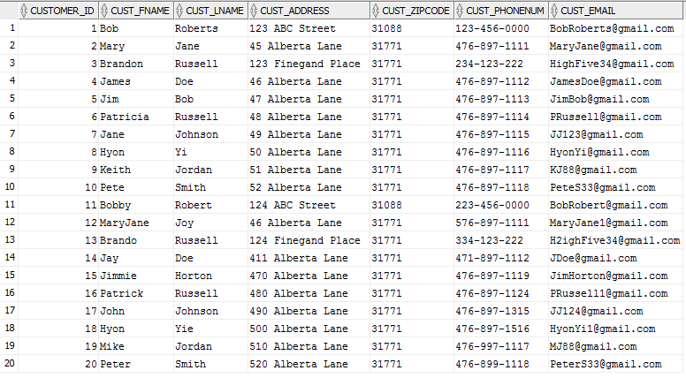

20 rows selected

SQL> SELECT /*fixed*/ * FROM CustomerOrder;

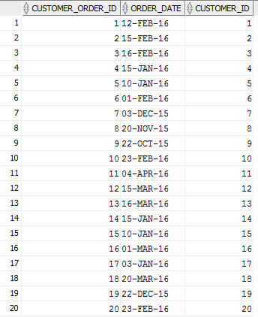

20 rows selected

SQL> SELECT /*fixed*/ * FROM OrderDetails;

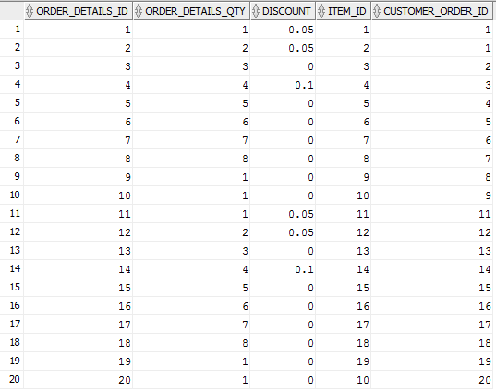

20 rows selected

SQL> SELECT /*fixed*/ * FROM Item;

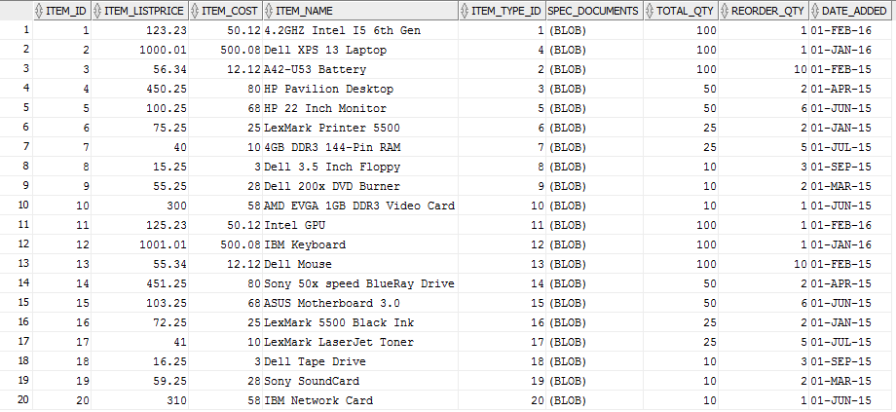

20 rows selected

SQL> SELECT /*fixed*/ * FROM ItemType;

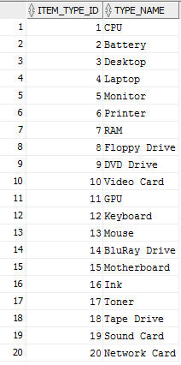

20 rows selected